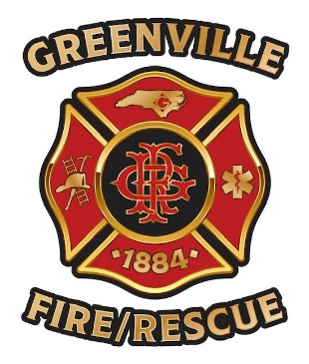

To Whom It May Concern,

For the past 30 plus years, Greenville Fire/Rescue has made Christmas truly special for hundreds of families. Since the development of our partnership with WTIB, there has been tremendous growth and support given to the Pitt County Operation Santa Claus Program. The outreach from the community and support with monetary donations for the annual Pitt County Operation Santa Claus would not be the success that it is today without Henry Hinton and his outstanding team at WTIB. Every December, I get to see first-hand the extraordinary impact that WTIB and its listeners make throughout Greenville and Pitt County, NC. The partnerships that has been created with WTIB has led to over seventy thousand dollars in monetary donations for the Pitt County Operation Santa Claus in December of 2022. Through the efforts of the WTIB’s Pitt County Operation Santa Annual Radiothon, our partnership with the station has assisted several hundred families with Christmas presents and toys for children they may not have received anything for Christmas if not for this partnership. During the last holiday season, Pitt County Operation Santa Claus had the largest monetary donation and toy shopping experience that we have ever had in the past thirty five years. To see the direct impact that the team at WTIB makes on local families at Christmas is truly magical.

Each year the continuous partnership with WTIB allows for the radio station’s annual Embers Concert, since COVID this concert has seen a huge increase in attendance and ticket sales which go directly towards purchasing more toys. None of these holiday community events would be possible without the overwhelming support from WTIB. Henry and his team go above and beyond to ensure that every child in Pitt County has a toy to call their own on Christmas morning. With WTIB’s generous support and continuous efforts the Pitt County Operation Santa Claus is able to make each Christmas bigger and better every year. In fact, last December the Pitt County Operation Santa Claus was able to sponsor more children and families than ever before. I believe that WTIB deserves radio station of year because of their generous response when they know their community need assistance and WTIB continues to generate new ideas and innovative way to ensure that this happens.

A special thank you WTIB for always being willing to go above and beyond to help bring the magic back to the holiday season for so many families.

Jessica Blackwell

Fire and Life Safety Educator/PIO

Greenville Fire/Rescue

jbblackwell@greenvillenc.gov

Desk: (252) 329-4679